

Software Development & Construction

Semester Project

Scalable E-Commerce Application using Microservices Architecture on AWS

SUPERVISOR: DR ZUNNURAIN HUSSAIN
COORDINATOR: SIR UMAIN MAKHDOOM

Muhammad Hamza BSSE23001
Muhammad Sarmad BSSE23013
Hafiz Azfar Umar Sheikh BSSE23064

Table of Contents
1. Project Proposal 3
1.1 Executive Summary 3
1.2 Introduction 4
1.3 Problem Definition 5
1.4 Aims and Objectives 6
2. AWS Architecture Design 6
2.1 Architectural Overview 6
2.2 Component Analysis 7
2.3 Data Flow Description 12
3. Implementation Report 12
3. Implementation Steps & Configuration 12
3.1 Phase 1: IAM, Network, and Security Configuration 13
3.2 Phase 2: Database and Persistence Layer 13
3.3 Phase 3: Containerization and ECS Deployment 13
3.4 Phase 4: Internal Load Balancing & Routing 14
3.5 Phase 5: Monitoring and Logging 14
4. Tables 14
4.1: Comparison of Monolithic vs. Microservices Architecture 14
5. References 16

List Of Figures
Figure 1 Architectural Diagram 7
Figure 2 VPC Configuration 8
Figure 3 ECS Running Services 9
Figure 4 Pipeline Lamda Function 9
Figure 5 ECS Task Definitions 10
Figure 6 ECR Image Repositories 10
Figure 7 DynamoDB Tables 11
Figure 8 Cache Configurations 11
Figure 9 ALB Security Group 12
Figure 10 App Security Group 12
Figure 11 Backend Security Group 12
Figure 12 NLB Security Group 13
Figure 13 Redis Security Group 13
Figure 14 ECR Repositories in Creation 15

List Of Tables
Table 1 Comparison between our implemenation and Monolithic Architecture 17

1. Project Proposal

1.1 Executive Summary
The Challenge: Scalability and Reliability in E-Commerce Modern retail enterprises face significant risks from rigid, monolithic legacy systems that cannot scale dynamically during traffic surges. This leads to increased latency, system-wide outages, and a degraded customer experience. The primary problem addressed in this project is the lack of architectural resilience and the operational overhead associated with managing manual infrastructure.
The Solution: A Decoupled Microservices Ecosystem This project implements the "Online Boutique" application—a cloud-native, microservices-based web platform designed for high availability and fault tolerance. By decomposing the application into specialized services (Frontend, Product Catalog, and Cart), the architecture ensures that components can be updated, scaled, or repaired independently without impacting the entire system.
AWS Implementation Strategy The solution is built on Amazon Web Services (AWS) using a multi-tiered virtual private cloud (VPC) across multiple Availability Zones (us-east-1a and us-east-1b). Key implementation pillars include:
- Orchestration: Amazon ECS with Fargate for serverless container management.
- Networking: A dual-load-balancer strategy utilizing a Public Application Load Balancer (ALB) for user ingress and an Internal Network Load Balancer (NLB) for high-performance service-to-service communication.
- Data Persistence: A hybrid storage model using Amazon DynamoDB for the product catalog and Amazon ElastiCache (Redis) for low-latency session management.
- Security: Rigid network isolation via private subnets and the enforcement of the Principle of Least Privilege through IAM Roles and fine-grained Security Groups.
Outcomes and Value Proffered The resulting implementation delivers a robust, production-ready environment. Key outcomes include a 99.9% availability target through multi-AZ deployment, automated scalability that adjusts compute resources based on real-time demand, and a reduced security attack surface by isolating the application logic from the public internet. This architecture provides a scalable blueprint for modern e-commerce demands.
.

1.2 Introduction

1.2.1 Project Background: The Digital Commerce Evolution
In the current global marketplace, the "Always-On" economy dictates that e-commerce platforms must maintain 100% availability regardless of regional traffic spikes or localized hardware failures. Historically, web applications were built using Monolithic Architectures, where the user interface, business logic, and database access were tightly coupled into a single service. While simple to deploy initially, monoliths create a "single point of failure"—a bug in the "Currency Converter" service could potentially crash the entire checkout process.

1.2.2 Domain Relevance: The Online Boutique
The "Online Boutique" is a cloud-native microservices domain designed to simulate a high-stakes retail environment. This domain is particularly relevant as it encompasses diverse technical requirements:
- State Management: Handling real-time updates to shopping carts.
- High-Volume Read Operations: Browsing vast product catalogs stored in NoSQL databases.
- Transactional Integrity: Ensuring orders are processed accurately through secure API gateways.
By using this domain, the project addresses real-world challenges faced by retailers during high-traffic events like Black Friday or Cyber Monday, where system elasticity is the difference between profit and lost opportunity.

1.2.3 Rich Context: The Shift to AWS Managed Services
The implementation of this boutique on Amazon Web Services (AWS) represents a shift toward the "Serverless-First" and "Container-as-a-Service" (CaaS) mindset. By utilizing Amazon ECS (Elastic Container Service) and Fargate, this project removes the overhead of managing physical or virtual servers.
The context of this project is rooted in the AWS Well-Architected Framework, specifically focusing on:
- Operational Excellence: Automated deployment of containerized tasks via Amazon ECR.
- Security: Implementing a multi-layered "Defense in Depth" strategy using VPC subnets and restricted Security Groups.
- Reliability: Deploying across multiple Availability Zones (us-east-1a and us-east-1b) to ensure the boutique remains online even if a data center fails.

1.3 Problem Definition
The rapid transition to "Digital-First" retail has exposed fundamental flaws in traditional infrastructure. This project addresses the following critical business and technical bottlenecks:

1.3.1 Vertical Scaling Inefficiency & Cost Overruns
In a monolithic framework, scaling is "all or nothing." If the Cart Service experiences a 300% surge during a flash sale, the entire application—including idle modules like "About Us" or "Contact"—must be duplicated across larger servers. This leads to prohibitive cloud costs and inefficient resource utilization, as organizations pay for compute power they do not technically require.

1.3.2 Cascading Systemic Failures
Tight coupling between services creates a "domino effect." A memory leak in a secondary service, such as the Currency Converter, can consume the shared resources of the entire instance, leading to a total site blackout. In the e-commerce domain, even minutes of downtime equate to significant revenue loss and permanent damage to brand reputation.

1.3.3 Data Contention and Latency
Legacy systems often rely on a single, centralized Relational Database Management System (RDBMS). During peak traffic, the database becomes a bottleneck due to connection exhaustion and high I/O wait times. The inability to separate "Read-Heavy" traffic (Browsing Products) from "Write-Heavy" traffic (Updating Carts) results in high latency, which directly correlates to increased cart abandonment rates.

1.3.4 Security Vulnerability and "Flat" Networks
Many traditional implementations lack internal network segmentation. If the web-facing frontend is compromised, an attacker gains lateral access to the entire server environment. The lack of Micro-segmentation (the ability to isolate the backend from the frontend) poses a severe risk to sensitive customer data and PCI-DSS compliance.

1.3.5 Deployment Velocity Stagnation
Because the entire application is a single unit, a minor update to the "Product Description" requires a full re-build and re-deployment of the entire platform. This creates a deployment bottleneck, preventing the business from responding quickly to market trends or urgent security patches, thereby stifling innovation.

1.4 Aims and Objectives
Aim: To architect and implement a production-grade, containerized e-commerce backend on AWS that replaces monolithic fragility with a resilient, decoupled microservices mesh.
Objectives:
- Infrastructure Isolation: Design a custom VPC with dual-tier subnetting (Public/Private) to eliminate direct internet exposure of the database and backend logic.
- Decoupled Load Balancing: Implement a tiered routing strategy using ALB for Layer 7 (HTTP/HTTPS) and NLB for Layer 4 (TCP) to optimize internal service discovery.
- Managed Persistence: Transition from a single-point RDBMS to a distributed model using Amazon DynamoDB (Global Scaling) and Amazon ElastiCache (In-memory session state).
- Observability: Integrate Amazon CloudWatch to provide real-time telemetry and logging for every independent container task, ensuring rapid "Mean Time to Recovery" (MTTR).

2. AWS Architecture Design

2.1 Architectural Overview
The proposed solution utilizes a multi-tier microservices architecture. The system is decoupled into discrete functional components communicating via REST APIs.
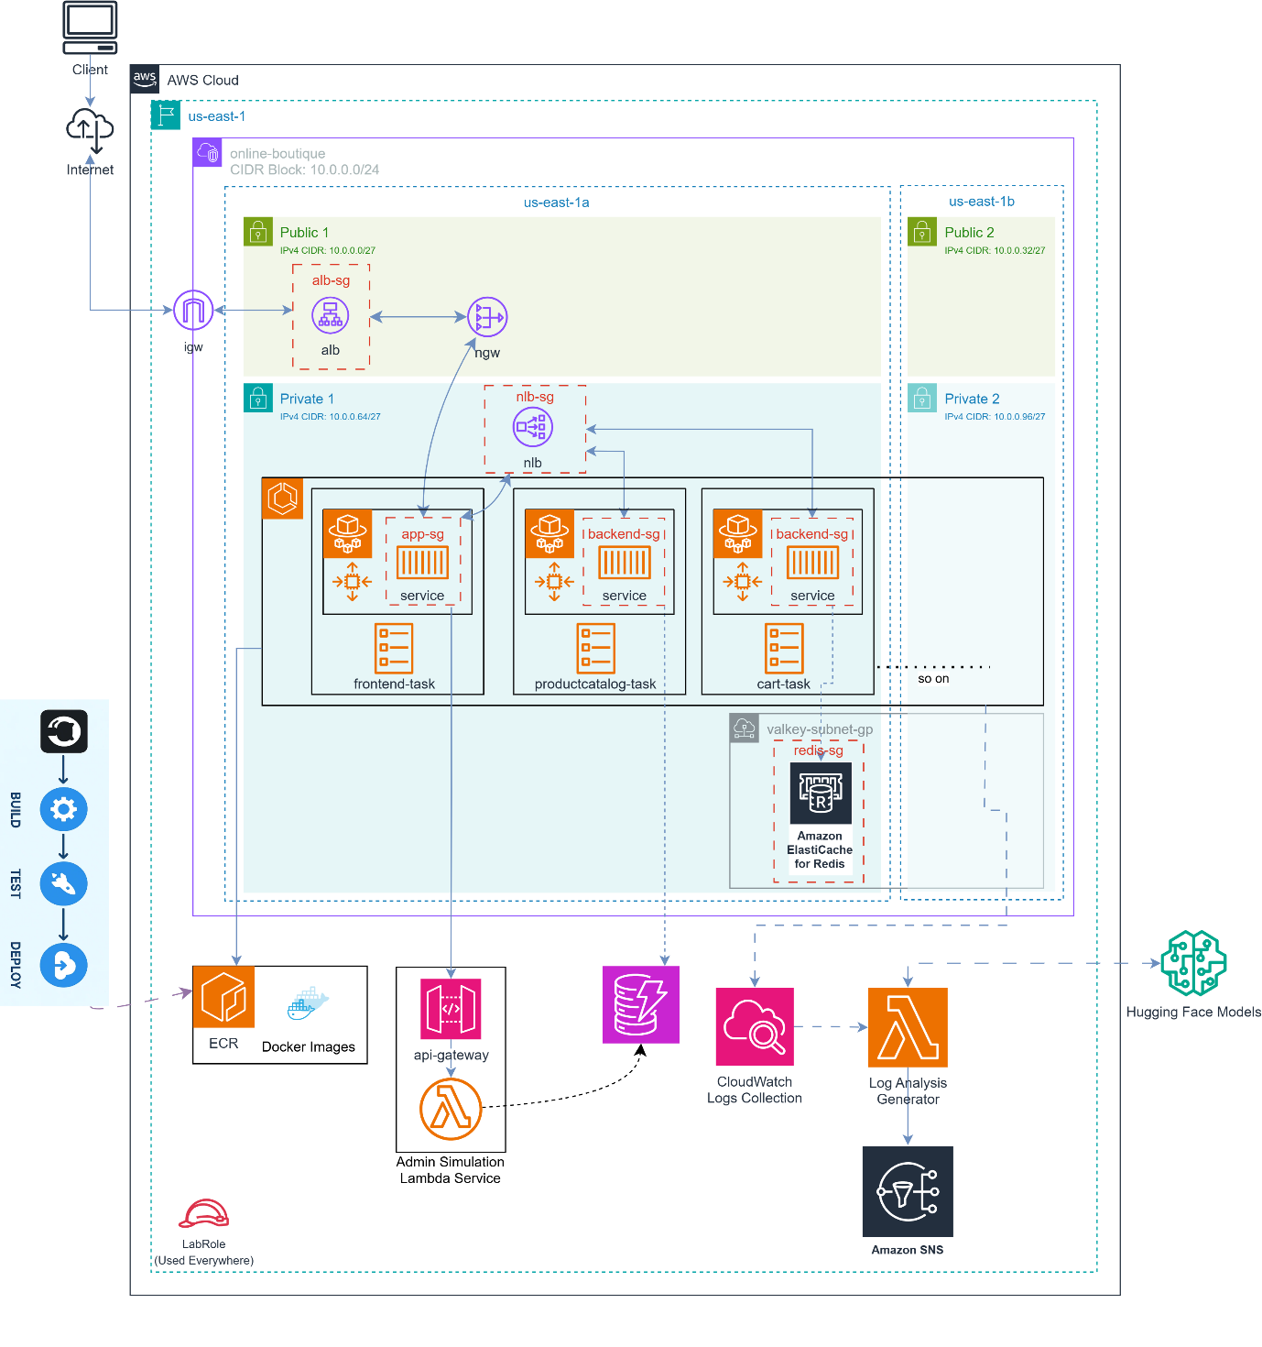
Figure 1 Architectural Diagram

2.2 Component Analysis
This section analyzes the infrastructure components shown in the architecture. Each component is vital for the high availability and security isolation of the boutique.

2.2.1 Networking & Connectivity
- Virtual Private Cloud (VPC): Provides a logically isolated network with CIDR 10.0.0.0/24.
- Public Subnets (us-east-1a/b): Host the public-facing ALB and NAT Gateway.
- Private Subnets (us-east-1a/b): Host the sensitive application logic and database endpoints.
- Internet Gateway (IGW): Allows communication between the VPC and the internet.
- NAT Gateway (NGW): Enables ECS tasks in private subnets to reach the internet for image updates while blocking unsolicited inbound traffic.
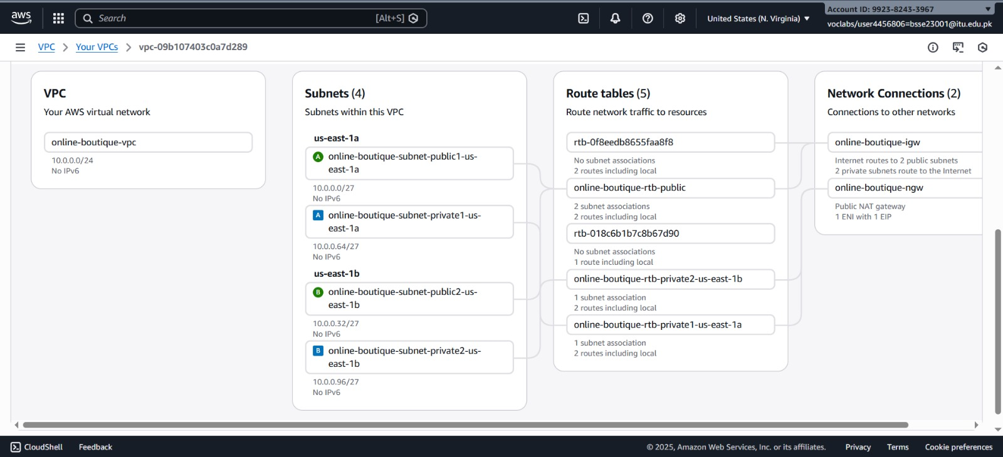
Figure 2 VPC Configuration

2.2.2 Compute Layer
- Application Load Balancer (ALB): Orchestrates external HTTP (Port 80) traffic to the Frontend service.
- Network Load Balancer (NLB): Provides ultra-low latency, internal TCP routing (Port 80) between the Frontend and Backend services.
- Amazon ECS (Fargate): Runs the containerized microservices (frontend-task, productcatalog-task, cart-task) in a serverless environment.
- AWS Lambda: Executes the "Admin Simulation" service, providing a serverless administrative backend.
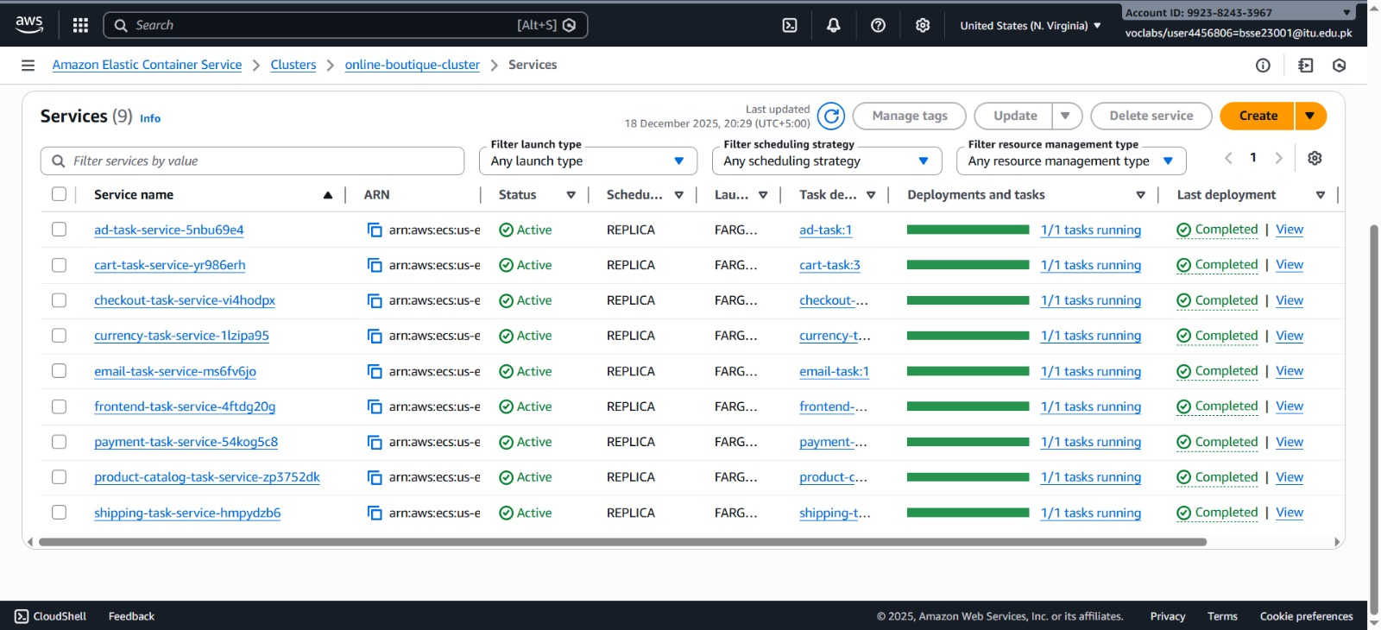
Figure 3 ECS Running Services
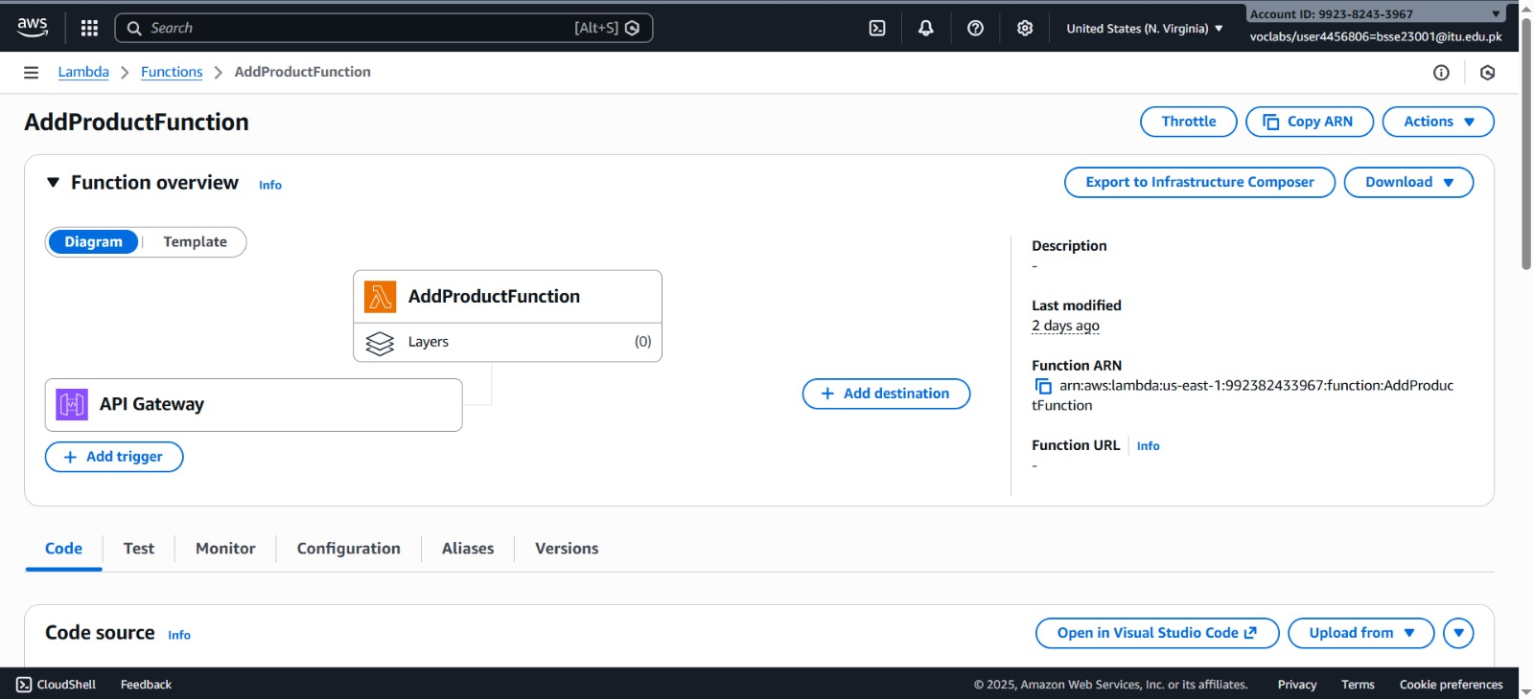
Figure 4 Pipeline Lamda Function
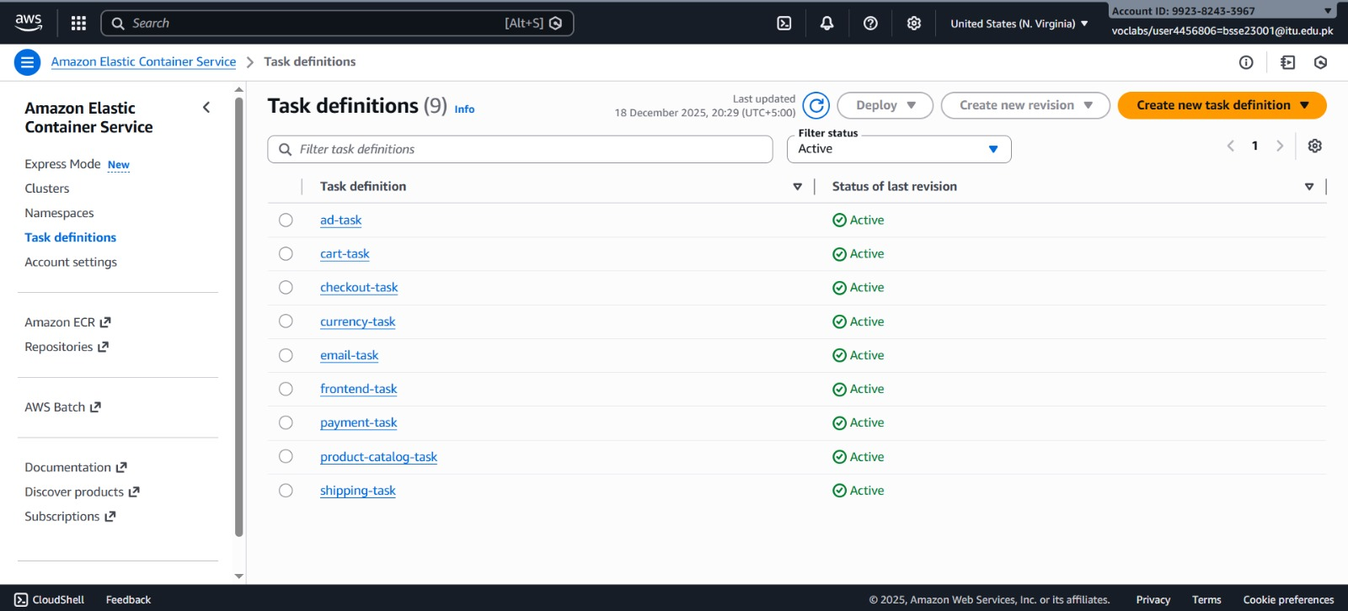
Figure 5 ECS Task Definitions

2.2.3 Storage & Database Layer
- Amazon DynamoDB: A regional, NoSQL database used for persistent product metadata.
- Amazon ElastiCache (Redis): Provides in-memory storage for high-speed sessional cart data.
- Amazon ECR: The container registry hosting the Docker images for all services.
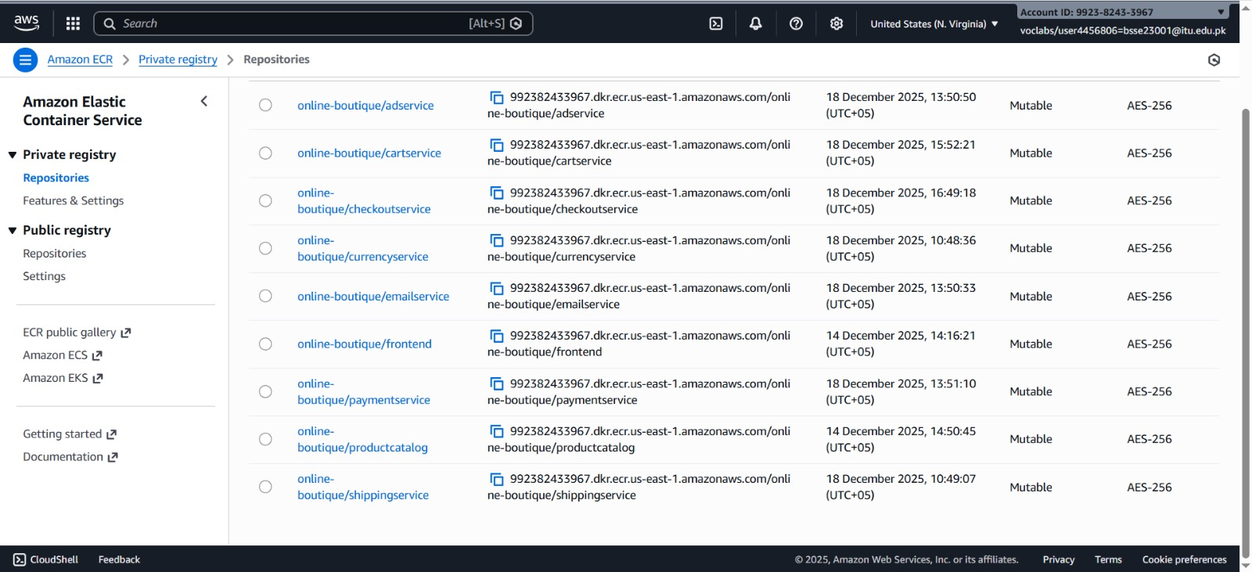
Figure 6 ECR Image Repositories
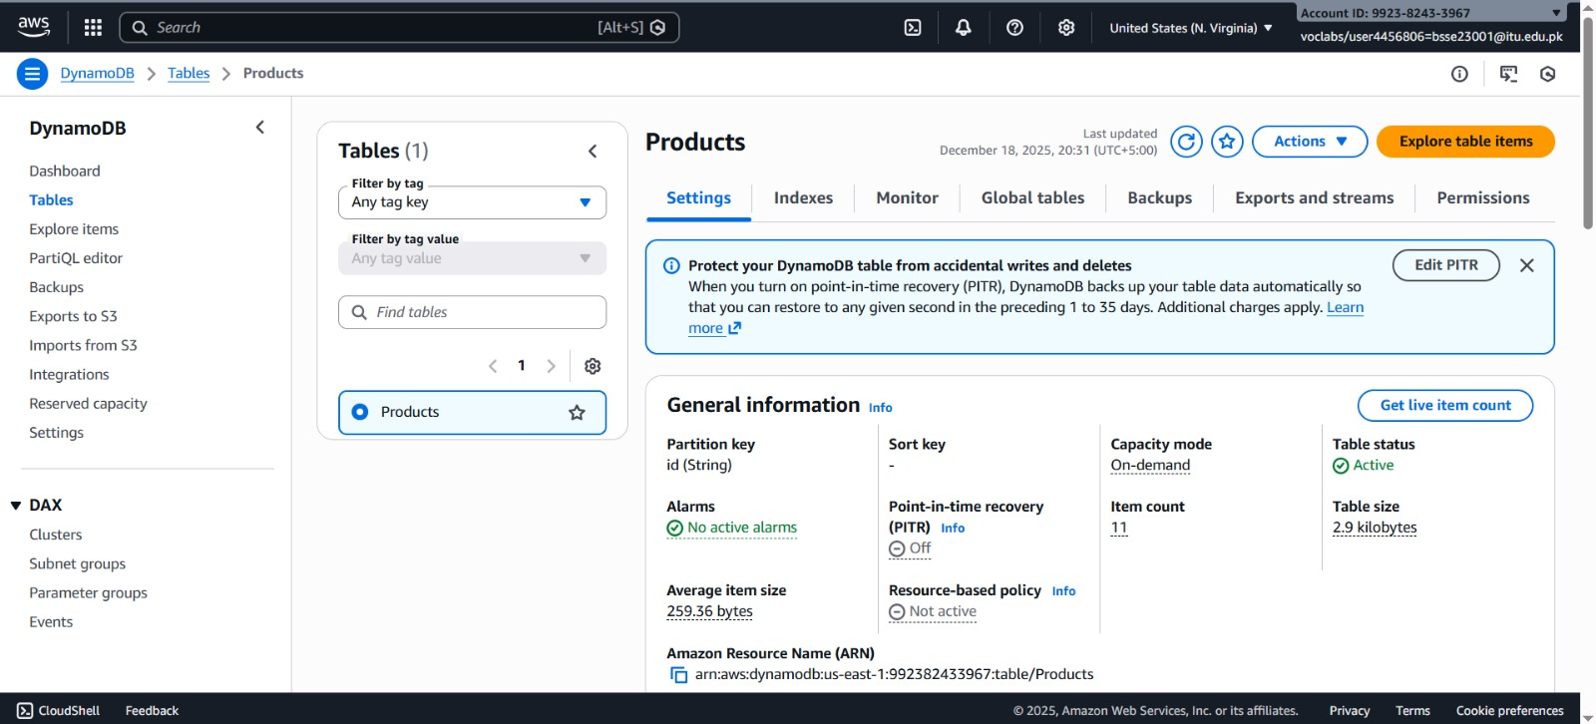
Figure 7 DynamoDB Tables
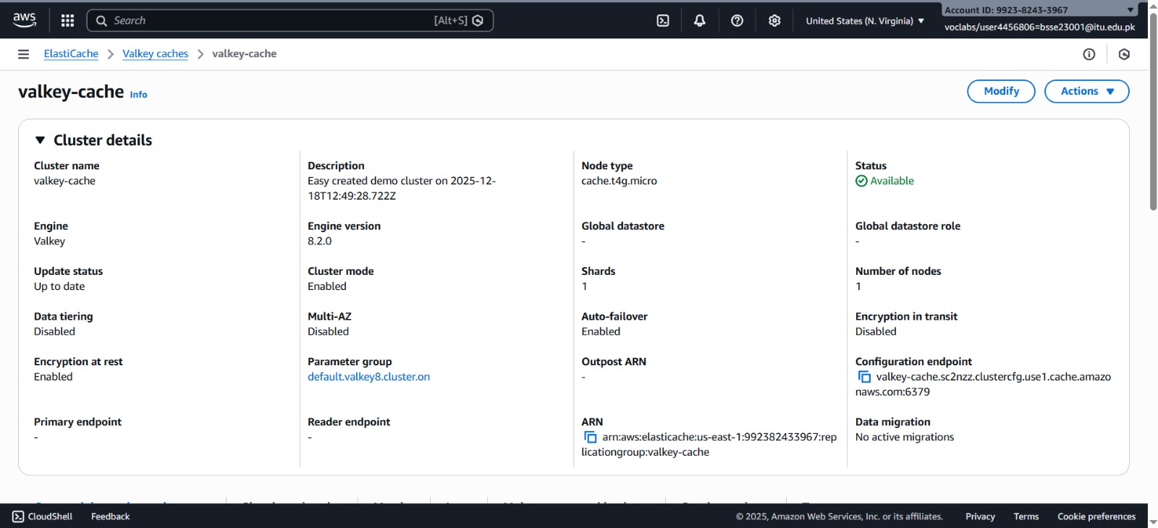
Figure 8 Cache Configurations

2.2.4 Security & Observability
- Security Groups (SG): Acts as a virtual firewall (e.g., alb-sg, frontend-sg, backend-sg).
- Amazon CloudWatch: Collects and visualizes logs from the ECS tasks and Lambda functions.
- IAM LabRole: Provides the necessary permissions for services to communicate securely.
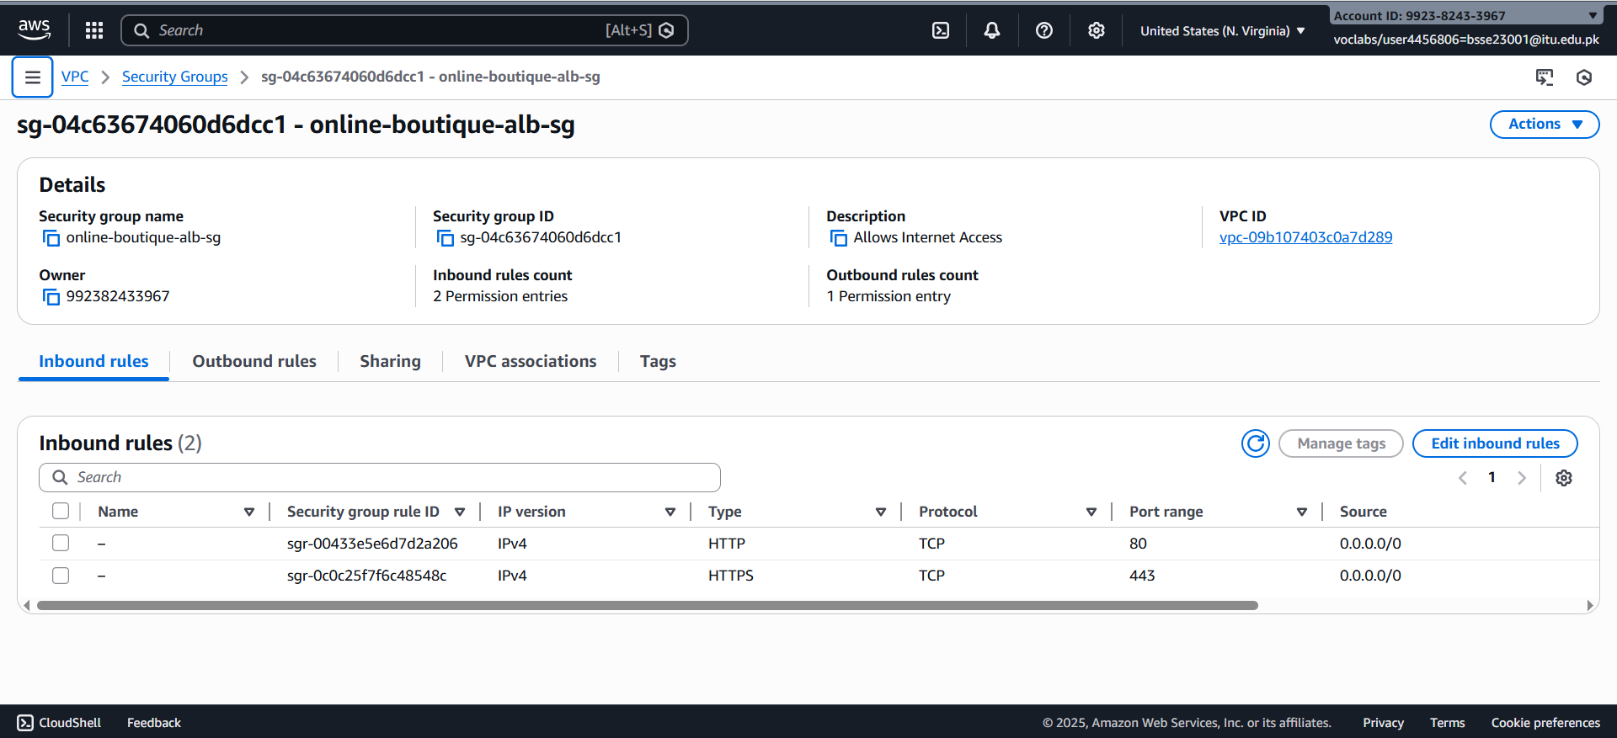
Figure 9 ALB Security Group
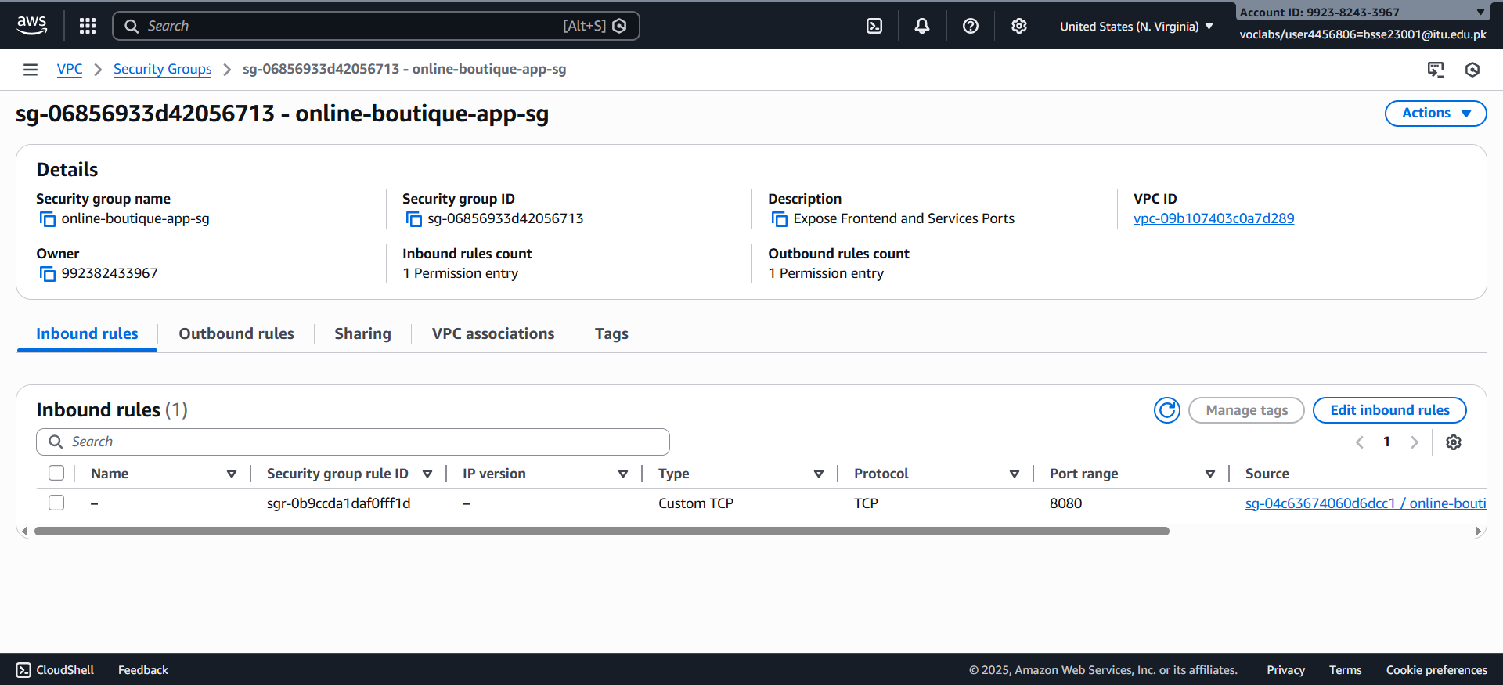
Figure 10 App Security Group
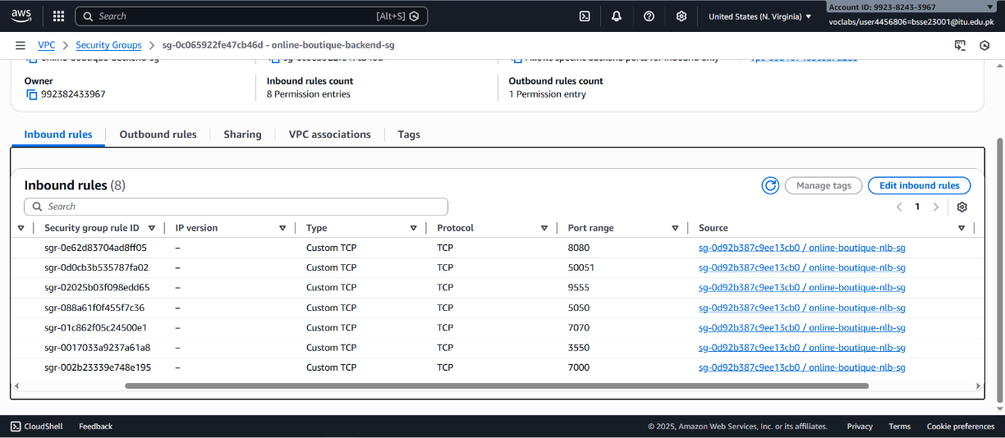
Figure 11 Backend Security Group
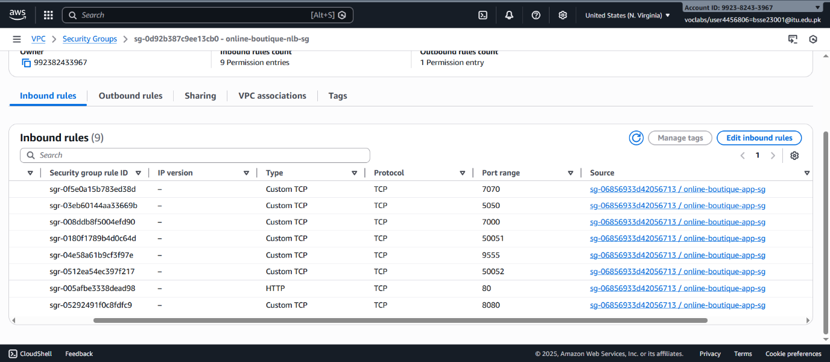
Figure 12 NLB Security Group
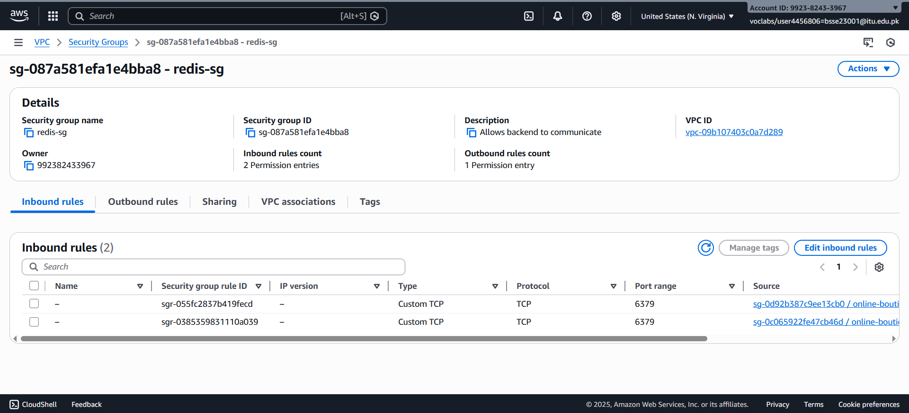
Figure 13 Redis Security Group

2.3 Data Flow Description
The traffic flow follows a Decoupled Request Pattern to ensure system stability.
- Client Entry: A user initiates a request via the internet, which passes through the IGW to the Public ALB.
- External Load Balancing: The ALB evaluates the request and forwards it to one of the Frontend Tasks residing in a Private Subnet (Security Group ensures traffic only comes from the ALB).
- Service Discovery: When the Frontend requires data (e.g., product details), it makes an internal call to the Internal NLB endpoint on Port 80.
- Internal Load Balancing: The NLB forwards the TCP packet to the appropriate Backend Task (Product or Cart).
- Data Persistence:
  - The Backend Task queries DynamoDB for product info or ElastiCache (Redis) for shopping cart state.
  - Lambda functions can perform administrative overrides or simulation tasks by calling the same database endpoints.
- Response Cycle: Data flows back from the Database => Backend Task => NLB Frontend Task => ALB User.
- Telemetry: Throughout this process, logs are streamed to CloudWatch for real-time monitoring and debugging.

3. Implementation Report

3. Implementation Steps & Configuration
This section documents the technical execution of the Online Boutique architecture. The implementation follows the "Least Privilege" security model, ensuring that only necessary ports are open between the tiered services.

3.1 Phase 1: IAM, Network, and Security Configuration
Objective: Establish a high-availability network foundation with strict isolation.
- IAM Roles & Policies:
  - LabRole / ECS Task Execution Role: Configured with policies to allow ecr:GetAuthorizationToken, ecr:BatchGetImage, and logs:CreateLogStream.
  - DynamoDB/ElastiCache Access: Assigned specific inline policies to the Backend Tasks to allow GetItem and PutItem operations.
- VPC & Subnetting:
  - VPC: Created with CIDR block 10.0.0.0/24.
  - Public Subnets: Defined Public 1 (10.0.0.0/27) and Public 2 (10.0.0.32/27) to host the Application Load Balancer (ALB) and NAT Gateway (NGW).
  - Private Subnets: Defined Private 1 (10.0.0.64/27) and Private 2 (10.0.0.96/27) to isolate the Frontend/Backend Tasks and the Internal NLB.
- Security Group Matrix (Firewall):
  - online-boutique-alb-sg: Allows HTTP (Port 80) from 0.0.0.0/0.
  - online-boutique-frontend-sg: Allows TCP (Port 8080) strictly from the alb-sg.
  - online-boutique-nlb-sg: Allows HTTP (Port 80) from the frontend subnet range.
  - online-boutique-backend-sg: Allows TCP (Port 3550) strictly from the nlb-sg.

3.2 Phase 2: Database and Persistence Layer
Objective: Deploy managed, high-performance data stores for product and session data.
- DynamoDB Implementation:
  - Provisioned a regional table for Product Data Storage.
  - Structure: Partition Key: ProductId (String).
- ElastiCache (Redis):
  - Deployed a Redis cluster for Sessional Cart Data Storage.
  - Configured the cluster inside the Private Subnets to ensure session data is never exposed to the public internet.

3.3 Phase 3: Containerization and ECS Deployment
Objective: Deploy microservices as serverless Fargate tasks.
- ECR Repositories: Created private repositories for currency-service, productcatalog-service, and cart-service.
- ECS Cluster: Created a cluster named online-boutique in the us-east-1 region.
- Task Definitions:
  - Defined container images, port mappings (8080 for frontend, 3550 for backend), and log configurations using the awslogs driver.
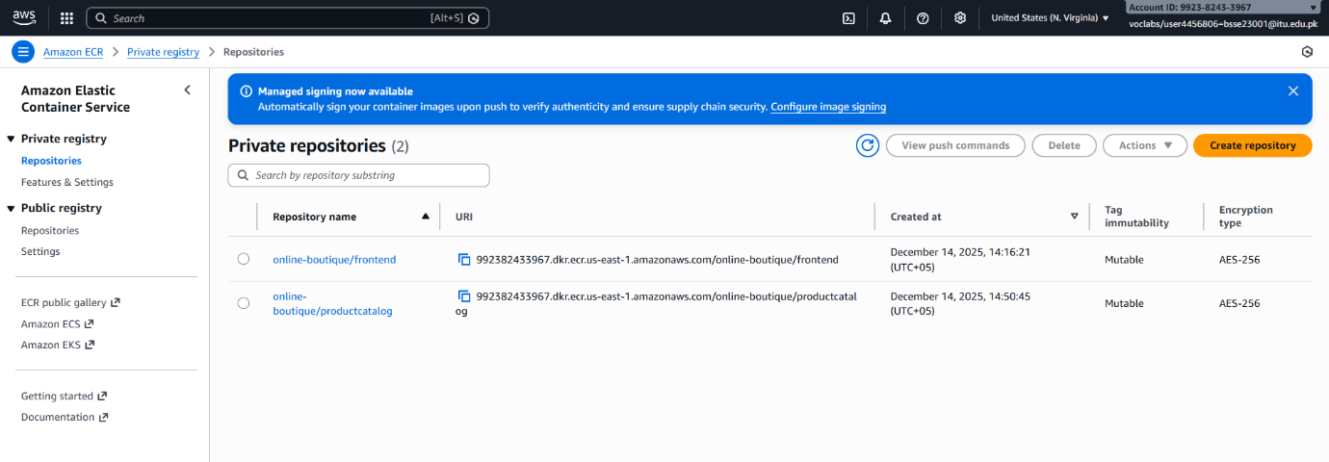
Figure 14 ECR Repositories in Creation

3.4 Phase 4: Internal Load Balancing & Routing
Objective: Enable secure service-to-service communication.
- Internal NLB: Configured a Network Load Balancer in the private subnets to handle traffic between the frontend and backend services via Port 80.
- Target Groups: Created target groups for each backend microservice, utilizing health checks to ensure traffic is only sent to "Healthy" containers.
- Lambda Admin Service: Deployed an "Admin Simulation" Lambda function to interact with DynamoDB for back-office tasks, triggered via an API Gateway.

3.5 Phase 5: Monitoring and Logging
Objective: Maintain visibility into system health and traffic.
- CloudWatch Logs Collection: All ECS tasks are configured to stream stdout to CloudWatch.
  - Path: /ecs/online-boutique-frontend and /ecs/online-boutique-backend.

4. Tables

4.1: Comparison of Monolithic vs. Microservices Architecture

Criteria | Monolithic Architecture | Microservices Architecture (AWS Implementation)
Scalability | Vertical/Unit Scaling: The entire stack must scale as one unit, leading to massive resource wastage and "over-provisioning." | Granular Horizontal Scaling: Uses ECS Service Auto Scaling to scale specific tasks (e.g., Frontend) independently based on CPU/Memory triggers.
Deployment Velocity | Coupled Releases: Single, large binary deployment. One minor change requires a full system rebuild and extended downtime. | Decoupled CI/CD: Independent service deployments via Amazon ECR. Faster "Time-to-Market" with zero-downtime rolling updates.
Fault Tolerance | Single Point of Failure: A memory leak in one module (e.g., Currency) propagates, causing a total system blackout. | Fault Isolation: Failures are contained within the container. If the Cart-task fails, users can still browse the Product-task via the Internal NLB.
Data Integrity & Performance | Centralized Contention: High I/O wait times due to all services fighting for a single RDBMS connection pool. | Polyglot Persistence: Optimized data stores. DynamoDB handles high-velocity product reads, while ElastiCache handles transient sessions.
Network Security | Flat Network: Minimal internal boundaries. A compromise of the web layer grants access to the database. | Micro-segmentation: Enforced by Security Groups. Traffic is strictly gated (e.g., Backend only accepts traffic from the Internal NLB).
Observability | Opaque Logs: Difficult to trace errors back to specific functions within a massive log file. | Distributed Tracing: Targeted monitoring via CloudWatch Log Groups for each individual microservice task.
Cost Optimization | Fixed Overhead: High costs due to running large instances even during low-traffic periods. | Elastic Consumption: AWS Fargate (Serverless) ensures you only pay for the exact vCPU/RAM utilized by active containers.
Table 1 Comparison between our implemenation and Monolithic Architecture

5. References
[1] Amazon Web Services, "AWS Architecture Center," aws.amazon.com, 2024. [Online]. Available: https://aws.amazon.com/architecture/. [Accessed: Nov. 28, 2025].
[2] M. Fowler and J. Lewis, "Microservices: A definition of this new architectural term," martinfowler.com, 2014. [Online]. Available: https://martinfowler.com/articles/microservices.html.
[3] S. Newman, Building Microservices: Designing Fine-Grained Systems. Sebastopol, CA: O'Reilly Media, 2015.
[4] W. Vogels, "Distributed Computing Manifesto," All Things Distributed (Amazon CTO Blog), 2023. [Online]. Available: https://www.allthingsdistributed.com/2022/11/amazon-distributed-computing-manifesto.html.

